[Organization Name]

Enterprise Architecture

[Insert Organization’s Logo Here]

[Business Focus Area Name]

Modernization Blueprint

[Business Focus Area Line of Business Name]

January, 2006

Table of Contents
1. Introduction 4
1.1 Purpose 4
1.2 Scope 4
1.3 Methodology 4
1.4 Document Overview 4
2. Executive Overview 5
3. Business Overview 5
3.1 Overview of the Business Area 5
3.2 Stakeholders including priorities 5
3.3 SWOT 5
3.4 Vision 5
3.5 Goals and Objectives 5
3.6 Overview of Business Products and Services 6
4. Recommendations for Business Transformation 6
4.1 Overview of Findings and Recommendations 6
4.2 Summary of Findings 6
4.3 Analysis of Recommendations 7
5. Target Solution Architecture 7
6. Target Data Environment 7
7. Transformation Sequence Plan 7
8. Appendix A - Supporting Tables and Figures 8
8.1 Business Analysis Tables and Figures 8
8.2 Findings and Recommendations 12
8.3 Target Architecture 14
8.4 Implementation Plan 15

List of Figures
Figure 2-1: Target Business Value Chain Product and Services 5
Figure 2-2: Stakeholder Hierarchy Diagram 6
Figure 2-3: Stakeholder Exchange Diagram 6
Figure 2-4: SWOT Analysis 7
Figure 2-5: Hierarchy of Goals and Objectives 8
Figure 3-1: VMM Value to Cost Comparison Chart 11
Figure 4-1: Strategic System Migration Diagram 12
Figure 5-1: Target Conceptual Data Model 12
Figure 6-1: Recommendation Implementation Overview 13
Figure 6-2: Transition Sequencing Plan 13

List of Tables
Table 3-1: Business Products and Services Matrix 8
Table 3-2: Summary of Findings for [Business Product or Service 1] 9
Table 3-3: Summary of Findings for [Business Product or Service 2] 9
Table 3-4: Summary of Findings for [Business Product or Service 3] 10
Table 3-5: VMM Analysis of Value, Cost and Risk 11

Introduction

Purpose
Briefly define the purpose of the document. This document provides a comprehensive Modernization Blueprint which defines the target state vision and transition plan for business transformation.

Scope
Briefly describe the scope of the Modernization Blueprint. This should be specific to the line of business within the business focus area.

Methodology
Describe how the MBT analysis was used in developing the modernization blueprint.
The Methodology for Business Transformation (MBT) was employed in developing the Modernization Blueprint. The MBT is a disciplined analysis best practice employed for developing strategic plans for business modernization. The methodology encapsulates analysis of all aspects of business and technology to deliver a complete modernization roadmap. MBT ensures a successful application of enterprise architecture disciplines in defining and analyzing a defined business focus area (BFA).

Document Overview
The Modernization Blueprint is comprised of five primary sections:
- Executive Overview: This is a brief (1-2 pages) overview that describes the motivation behind the Modernization Blueprint. It is focused on providing clear, concise answers to key questions, such as: Where are we? Where do we want to go? How do we get there?
- Business Overview: Provides a quick reference to the opportunities for improvement and a general context for maturity of the business focus area (BFA) line of business (LoB). Provides a brief description of the business functions and services that are provided and the strategic objectives that are to be achieved by the transformation.
- Recommendations for Business Transformation: Describes the existing architecture issues from a variety of perspectives. The Findings and Recommendations (F&R) are described in the context of the specific business products and services where improvements are recommended due to strategic drivers such as eliminating redundancies, filling voids, or other general industry trends. All findings are associated to specific recommendations on how to proceed.
- Target Technology Environment: Describes target state for the technology environment required to support the business transformation recommendations and the strategic systems migration plan.
- Target Data Environment: Describes the target conceptual data model and environment.
- Transition Sequence Plan: Describes the findings in the form of the integrated steps required to take the recommendations and begin to prioritize, develop business cases or investment proposals, initiate projects, or develop policy.
- Appendix A: This section includes all supporting tables and figures.
- Appendix B: This optional section includes any supporting reports derived from the Enterprise Architecture (EA) Repository describing the analytical relationships between the system artifacts.

Executive Overview
Provide a brief (1-2 pages) overview describing the motivation behind the Modernization Blueprint. Focus on providing clear, concise answers to key questions, such as: Where are we? Where do we want to go? How do we get there?

Business Overview
The purpose of this section of the document is to explain why this Blueprint was done. The executive audience needs to understand "why" this document has come to them. Tell the story of "what" has happened in the past (background) and "how" the proposed Modernization Blueprint will alleviate that pain (conclusion). Summarize what benefits the stakeholders will derive from implementing the recommendations.
Include a paragraph that covers the high priority findings and recommendations. Where appropriate, include the page number reference to the detailed findings and recommendations to which the reader may refer for additional information.
Also include a brief summary of the risk planning, monitoring, and transition scoping activities. This should be a very high level discussion.

Overview of the Business Area
Describe the business focus area, including an overview of the mission of the organization. This should also include an overview of the target business value chain and the associated products and services. Reference Figure 7-1: Target Business Value Chain Product and Services.

Stakeholders including priorities
This section describes the stakeholders of the business focus area. The stakeholder hierarchy and stakeholder exchange diagrams can be included. This section should also describe which stakeholders were determined to be most important, and how this prioritization was developed. Reference Figure 7-2: Stakeholder Hierarchy Diagram and Figure 7-3: Stakeholder Exchange Diagram.

SWOT
The SWOT analysis is included for the high-priority stakeholders. Reference Figure 7-4: SWOT Analysis.

Vision
This section describes the to-be state. Using the SWOT analysis, describe which specific elements of the SWOT are to be addressed as part of the Modernization Blueprint, and how these elements relate to the stakeholder needs.

Goals and Objectives
This section summarizes the goals and objectives of the organization with respect to eh business focus area. A hierarchy of goals and objectives may be included to illustrate the relationships. The end outcomes and intermediate outcomes will provide the basis for deriving the business value associated with specific recommendations. Reference Figure 7-5: Hierarchy of Goals and Objectives.
End Outcomes (EO) are long term performance goals which describe and support the organization’s strategic goals. End Outcomes express a desired result and are measured by one or more performance measures or indicators. Performance measures indicate the success in achieving the long-term goal. Intermediate Outcomes describe and support major milestones of an annual End Outcome goal. There are two or more Intermediate Outcome Goals to every End Outcome Goal. These outcomes provide key guiding criteria and principles in identifying issues and formulating recommendations.

Overview of Business Products and Services
This section includes a detailed discussion on each product and service from the Products and Service Matrix including the maturation of each written as findings and recommendations. Reference Table 7-2: Business Products and Services Matrix.

Recommendations for Business Transformation
This section describes how the Business Focus Area should change to meet stakeholder needs.

Overview of Findings and Recommendations
In this introductory section, provide a high-level summary of the findings and recommendations.

Summary of Findings
This section will provide a more detailed summary of the findings and recommendations that are used to develop an integrated activity plan that the business owners use to develop a prioritized strategy to drive the business improvement process. These activities may take the form of formal business case submission(s), business process re-engineering, systems integration, partnerships or policy development as well as other methods. The primary value of the integrated plan is to provide a management tool to ensure a coordinated vision and strategy for future investments and internal collaboration.
Repeat the section below for each service type as defined in the service reference model for which findings and recommendations are developed.

Service Type: [Insert Service Type Label]
Provide a brief description of the service type. Repeat the findings section below for each finding associated with the service type.

Finding: [Insert Finding Label]
Provide a brief summary of the finding. Findings are developed so as to correspond with an associated service type.

Recommendation: [Insert Recommendation Label]
Provide an overview of the recommendation or alternative. Specify which sets of recommendations are presented as simple recommendations (i.e., options that can be implemented independently) or alternatives (i.e., mutually exclusive sets of recommendations).

Summary of Recommendations
For all recommendations or alternatives associated with the service area, summarize them using the table below. Note that each item listed in the table (ID #) will correspond to a line-item to be analyzed using the VMM methodology in the Analysis of Recommendations.
Table 3-1: [Insert Service Area Label]
ID | Recommendation / Alternative Description | Cost | Value | Risk
ID # | Provide a brief description of the recommendation or alternative. | Summary of the overall cost associated with implementation. Include decommissioning costs. | Summary of the overall value associated with implementation. Include decommissioning costs. | Summary of the overall risk associated with implementation. Include decommissioning costs.

Analysis of Recommendations

Value Measurement Methodology (VMM) Analysis Results
Describe the VMM analysis performed for each recommendation and alternatives. Note that recommendations and alternatives are rolled up in the VMM analysis. Reference Table 7-3: VMM Analysis of Value, Cost and Risk and Figure 7-6: VMM Value to Cost Comparison Chart.

Target Solution Architecture
Include a discussion of the target technology environment. This discussion can be easily developed using the executive overview in the Solution Architecture document. The strategic systems migration diagram and the Strategic Sequencing Overview Visual are used to illustrate the transition to the target systems environment. Reference Figure 7-7: Strategic System Migration Diagram and Figure 7-8: Strategic Sequencing Overview.

Target Data Environment
Include a discussion of the target data environment. This may include a discussion of the conceptual data model, which provides a high level representation of the organizational data. This model helps describe the basic building blocks for the organization, including the entities and rules about their meaning and interrelationships. Reference Figure 7-9: Target Conceptual Data Model.

Transformation Sequence Plan
Discuss the business transformation sequencing plan for implementing the recommendations. Describe how the recommendations were prioritized. The discussion should also cover the risks and costs associated with implementation. Reference Figure 7-10: Recommendation Implementation Overview and Figure 7-11: Transition Sequencing Plan.

Appendix A - Supporting Tables and Figures

Business Analysis Tables and Figures

Tables
Table 7-2: Business Products and Services Matrix
Business Product or Service | Level 0 (Current State) | Level 1 | Level 2 | Level 3
Business Product or Service 1 | - Business Product or Service Detail  - Business Product or Service Detail  - Business Product or Service Detail  - Business Product or Service Detail  - Business Product or Service Detail  - Business Product or Service Detail | - Business Product or Service Detail  - Business Product or Service Detail  - Business Product or Service Detail  - Business Product or Service Detail  - Business Product or Service Detail  - Business Product or Service Detail | - Business Product or Service Detail  - Business Product or Service Detail  - Business Product or Service Detail  - Business Product or Service Detail  - Business Product or Service Detail  - Business Product or Service Detail | - Business Product or Service Detail  - Business Product or Service Detail  - Business Product or Service Detail  - Business Product or Service Detail  - Business Product or Service Detail  - Business Product or Service Detail
Business Product or Service 2 | - Business Product or Service Detail  - Business Product or Service Detail  - Business Product or Service Detail  - Business Product or Service Detail  - Business Product or Service Detail  - Business Product or Service Detail | - Business Product or Service Detail  - Business Product or Service Detail  - Business Product or Service Detail  - Business Product or Service Detail  - Business Product or Service Detail  - Business Product or Service Detail | - Business Product or Service Detail  - Business Product or Service Detail  - Business Product or Service Detail  - Business Product or Service Detail  - Business Product or Service Detail  - Business Product or Service Detail | - Business Product or Service Detail  - Business Product or Service Detail  - Business Product or Service Detail  - Business Product or Service Detail  - Business Product or Service Detail  - Business Product or Service Detail
Business Product or Service 3 | - Business Product or Service Detail  - Business Product or Service Detail  - Business Product or Service Detail  - Business Product or Service Detail  - Business Product or Service Detail  - Business Product or Service Detail | - Business Product or Service Detail  - Business Product or Service Detail  - Business Product or Service Detail  - Business Product or Service Detail  - Business Product or Service Detail  - Business Product or Service Detail | - Business Product or Service Detail  - Business Product or Service Detail  - Business Product or Service Detail  - Business Product or Service Detail  - Business Product or Service Detail  - Business Product or Service Detail | - Business Product or Service Detail  - Business Product or Service Detail  - Business Product or Service Detail  - Business Product or Service Detail  - Business Product or Service Detail  - Business Product or Service Detail
Yellow = 1-2 year target
Blue = 3-5 year target

Figures
Figure 7-1: Target Business Value Chain Product and Services
Figure 7-2: Stakeholder Hierarchy Diagram
Figure 7-3: Stakeholder Exchange Diagram
Figure 7-4: SWOT Analysis
Figure 7-5: Hierarchy of Goals and Objectives

Findings and Recommendations

Tables
Table 7-3: VMM Analysis of Value, Cost and Risk
Blueprint Recommendation | Measure Value |  |  |  |  | Measure Risk |  |  |  |  | Measure Cost
Recommendation | Customer Results | Mission and Business Results | Processes and Activities | Strategic Alignment | Financial Results | Description of  Risks | Likelihood of Risk Occurring | Impact of Risks on Costs | Impact of Risks on Value | Risk Management  Strategy | Estimated Cost
 | (Weights for Each Measure)
 | 0.2 | 0.2 | 0.2 | 0.2 | 0.2
Recommendation 1 | 2 | 2 | 2 | 2 | 2 |  | High | Med | Med |  | 4
Recommendation 2 | 3 | 3 | 3 | 3 | 3 |  | Med | Med | Med |  | 3
Recommendation 3 | 4 | 4 | 4 | 4 | 4 |  | Med | Med | Med |  | 7
Recommendation 4 | 5 | 5 | 5 | 5 | 5 |  | Med | Med | Med |  | 8
Recommendation 5 | 7 | 7 | 7 | 7 | 7 |  | High | High | High |  | 9
Recommendation 6 | 9 | 9 | 9 | 9 | 9 |  | Med | Med | Med |  | 1

Figures
Figure 7-6: VMM Value to Cost Comparison Chart

Target Architecture

Figures
Figure 7-7: Strategic System Migration Diagram
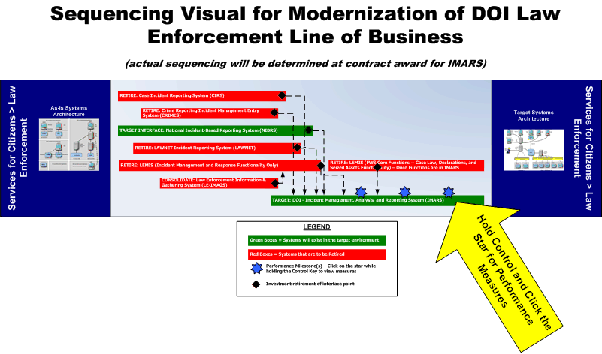
Figure 7-8: Strategic Sequencing Overview
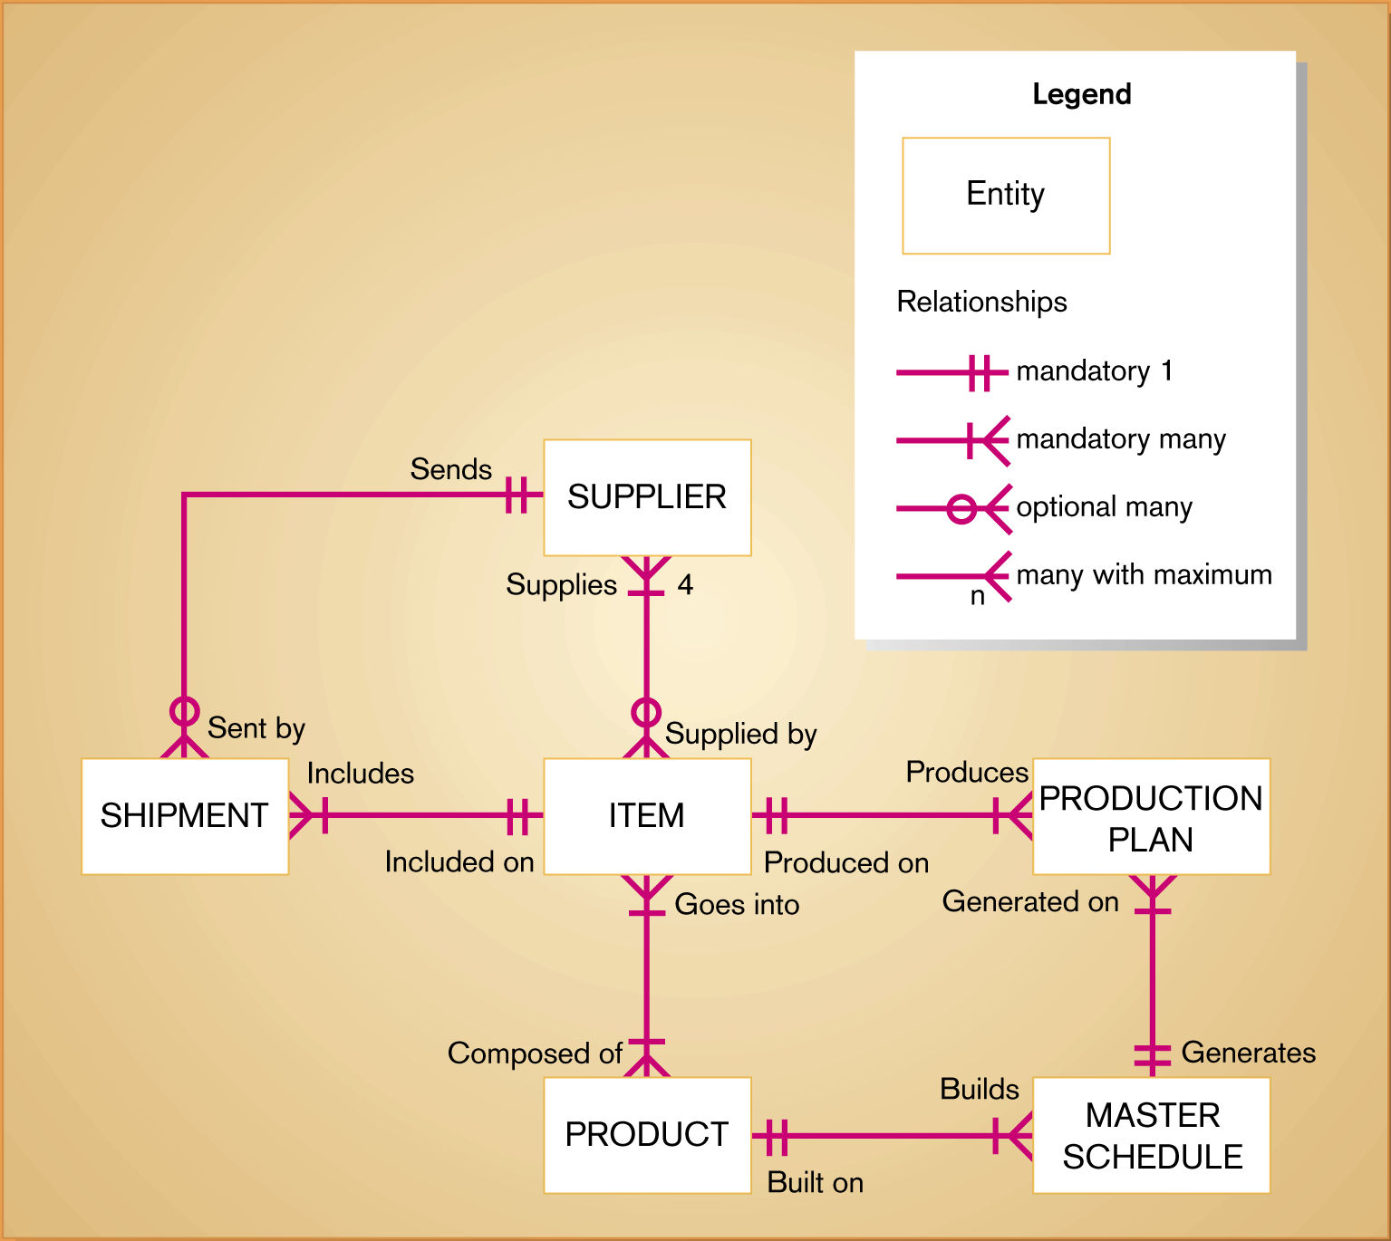
Figure 7-9: Target Conceptual Data Model

Implementation Plan

Figures
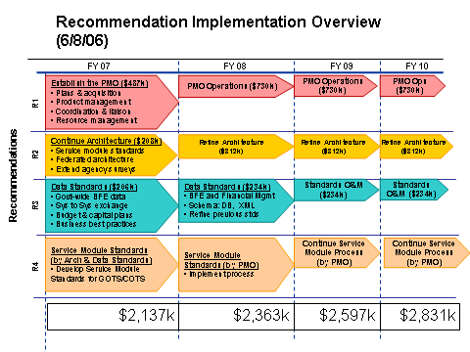
Figure 7-10: Recommendation Implementation Overview
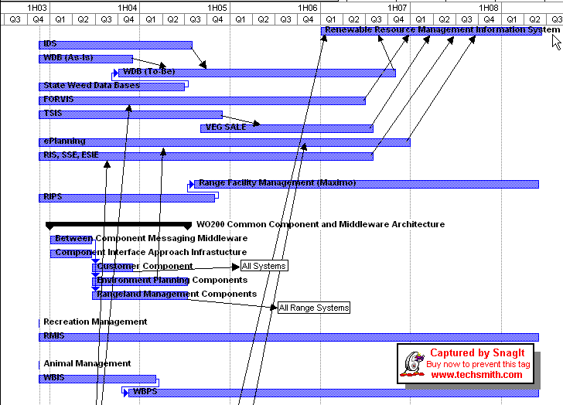
Figure 7-11: Transition Sequencing Plan

